**TASK-4**

**QUESTION**

1-Create an experience fragment and place the created sidebar component in it and author

2- Create a template and place the experience fragment in created template, then using the template create the page.

The created page should contain the experience fragment in it with authored values

**Task 1:** Create an Experience Fragment and Place the Created Sidebar Component in It

**Objective:**  Create an Experience Fragment (XF) in AEM, add a Sidebar component to it, and author the Sidebar component with necessary content.

**Steps:**

1. **Create the Sidebar Component:**
   * Ensure you have a Sidebar component created in AEM.
   * The Sidebar component should be able to be authored with required fields (e.g., text, links, images).

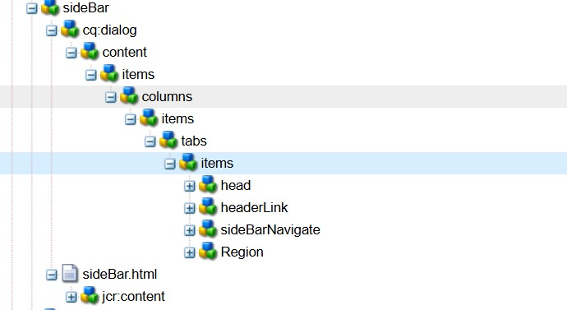

**Create the Experience Fragment:**

* Navigate to **Experience Fragments** in AEM.
* Create a new Experience Fragment by selecting **Create** > **Experience Fragment**.
* Fill in the required fields (Title, Name) and choose the appropriate template for the Experience Fragment.

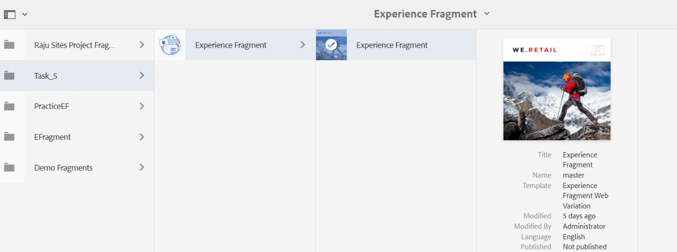

**Add Sidebar Component to the Experience Fragment:**

* Open the created Experience Fragment.
* In the editor, use the **Components** browser to find your Sidebar component.
* Drag and drop the Sidebar component into the Experience Fragment.
* Author the Sidebar component with the desired content.

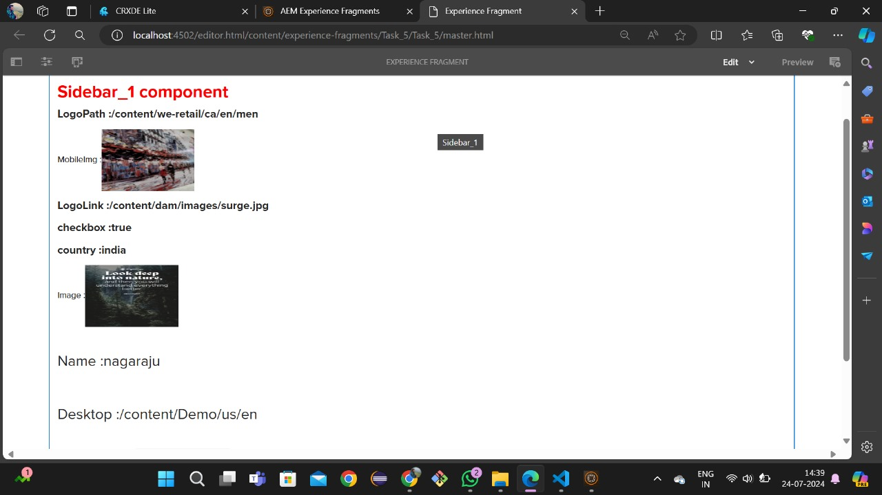

**Save and Activate the Experience Fragment:**

* After authoring the Sidebar component, save your changes.
* Activate (publish) the Experience Fragment to make it available for use on published pages.

**Task 2: Create a Template and Place the Experience Fragment in the Created Template**

**Objective:** Create a template in AEM, add the Experience Fragment created in Task 1 to this template, and use this template to create a page. The page should contain the Experience Fragment with the authored values.

**Steps:**

1. **Create a Template:**
   * Navigate to **Tools** > **General** > **Templates** in AEM.
   * Click **Create** to start a new template.
   * Choose an appropriate **Template Type** and provide necessary details like title, description, etc.

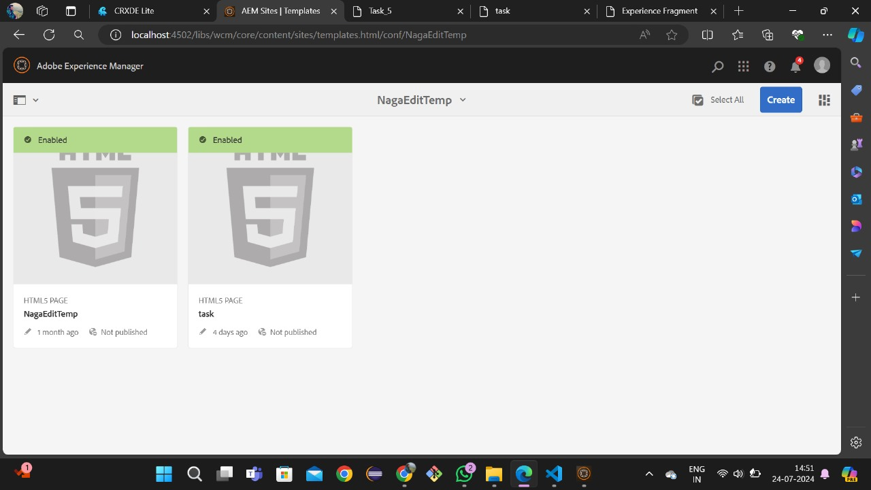

• Edit **the Template Structure:**

* Open the template editor.
* Add a **Layout Container** (or another suitable container) to the template if not already present.

• Add **the Experience Fragment to the Template:**

* Within the Layout Container, use the **Components** browser to find the **Experience Fragment** component.
* Drag and drop the Experience Fragment component into the Layout Container.
* Configure the Experience Fragment component to point to the Experience Fragment you created in Task 1.

**Save and Enable the Template:**

* Save your changes in the template editor.
* Navigate to the template details page and **Enable** the template to make it available for page creation.

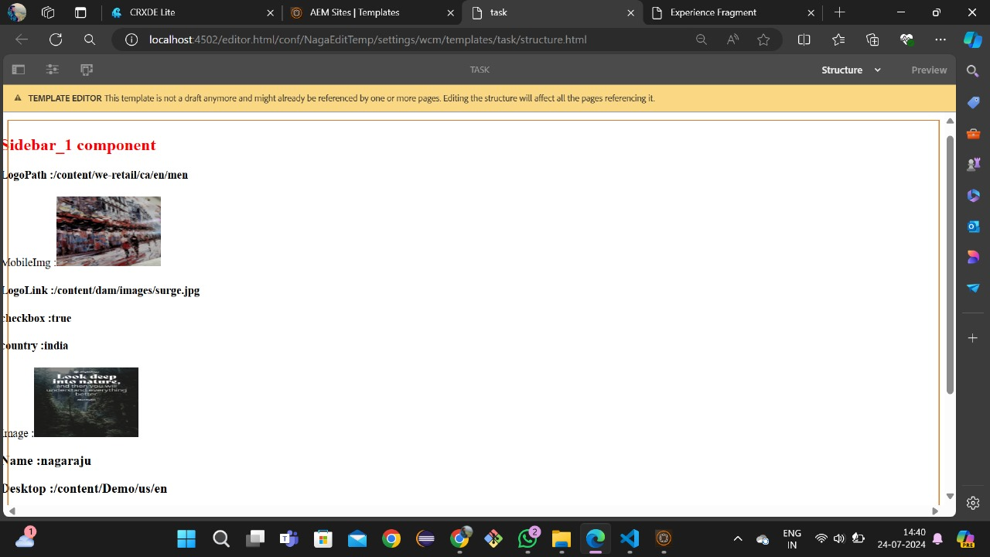

**Task 3: Create a Page Using the Template**

**Objective:** Create a new page using the template from Task 2. The created page should include the Experience Fragment with the authored Sidebar component.

**Steps:**

1. **Create a New Page:**
   * Navigate to **Sites** in AEM.
   * Choose the appropriate site where you want to create the page.
   * Click **Create** > **Page**.
   * Select the template you created in Task 2.
   * Fill in the required fields (Title, Name) for the new page.

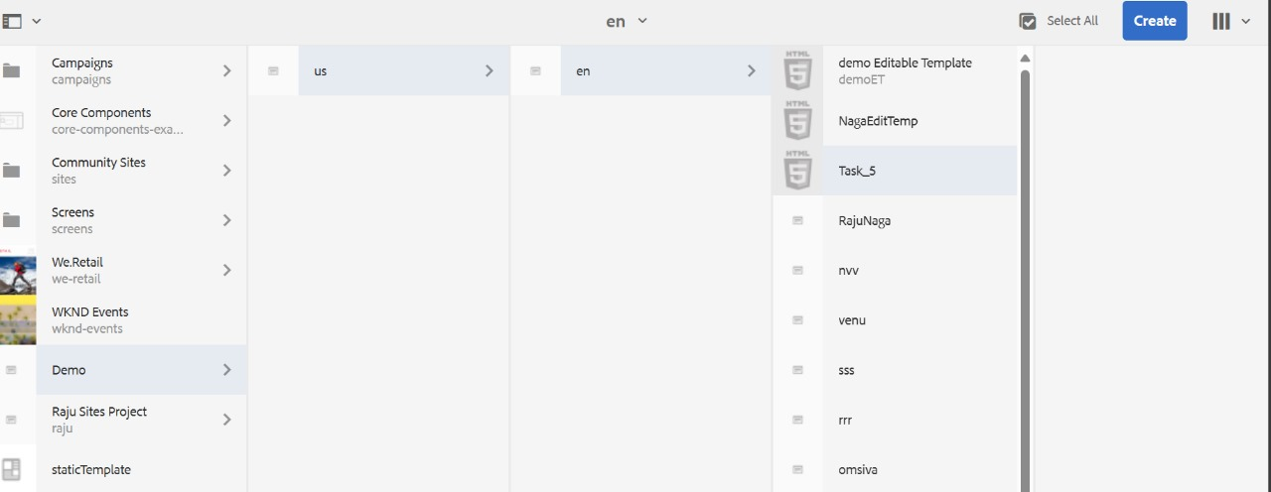

1. **Verify the Page Content:**
   * Open the newly created page in the editor.
   * Verify that the Experience Fragment is included in the page.
   * Ensure the Sidebar component within the Experience Fragment is displaying the authored content correctly.
2. **Activate the Page:**
   * Save the page.
   * Activate (publish) the page to make it live and accessible on the published site.

